**Practice SQL Questions**

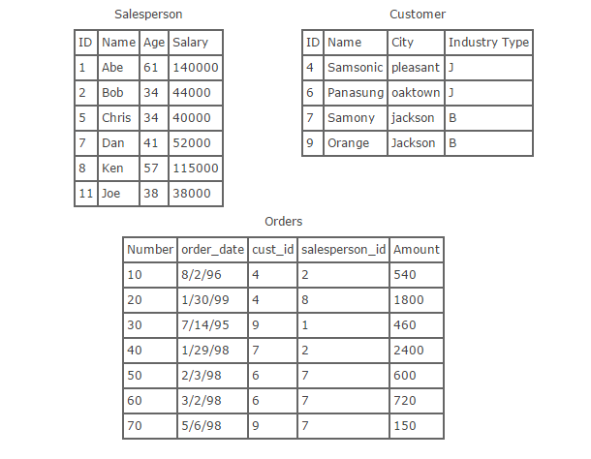

**Given the tables above, find the following:**  
a. The names of all salespeople that have an order with Samsonic.  
b. The names of all salespeople that do not have any order with Samsonic.   
  
c. The names of salespeople that have 2 or more orders.   
  
d. The names and ages of all salespersons must having a salary of 100,000 or greater.  
  
e. What sales people have sold more than 1400 total units?  
  
f. When was the earliest and latest order made to Samony?